Name : Abdul Majid

ID : F2023266946

**1) Natural Soap :**

Materials Needed

Soap Base: (e.g., glycerin or goat milk soap base)

Aloe Vera Gel: Pure aloe vera gel, store-bought or homemade

Neem Essential Oil: Few drops (according to preference)

Heat-Resistant Container: For melting the soap base

Spatula or Spoon: For stirring

Microwave or Double Boiler: For heating the soap base

Step-by-Step Process

Step 1:

Prepare Your Workspace Clean your workspace thoroughly.

Gather all the materials and tools you will need.

Wear gloves and ensure proper ventilation.

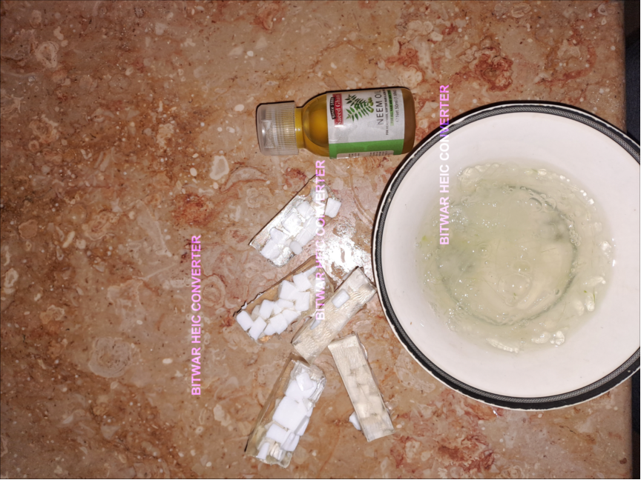

Step 2:

Melt the Soap Base Cut the soap base into small cubes for even

melting.

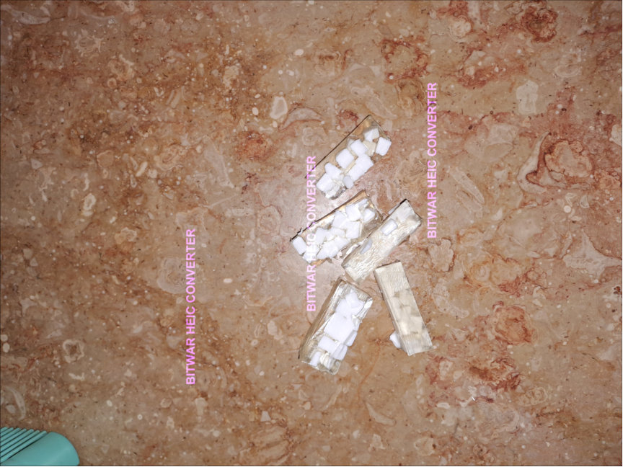

Step : 3

take a sauce and add water in it to boil

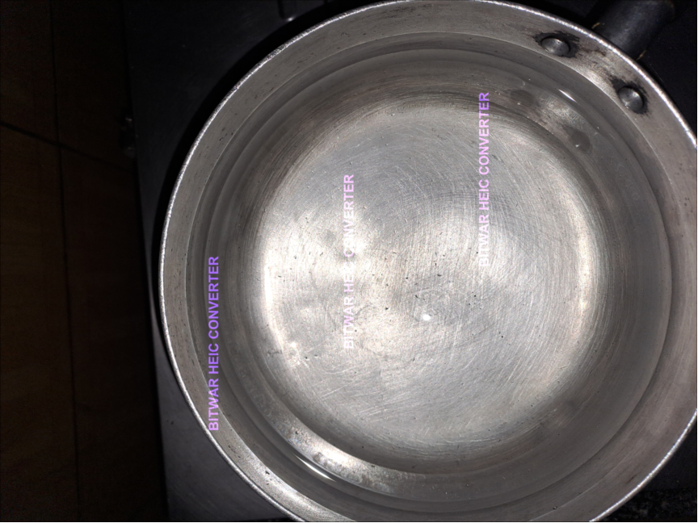

Step : 4:

Place a double boiler in it and add all the ingreadients

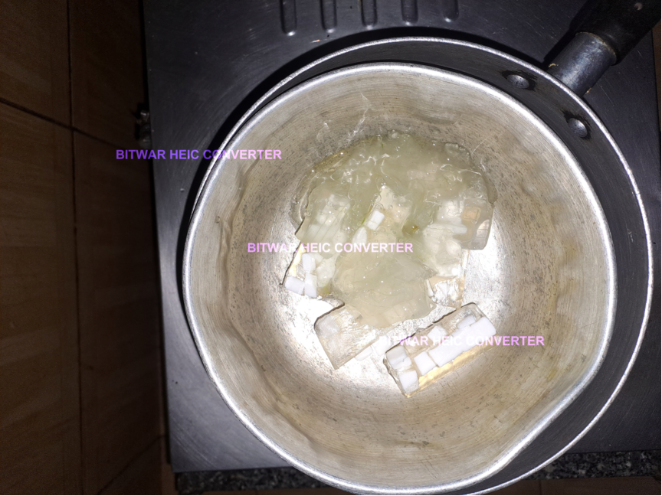

Step : 5

Melt all the ingreadeints stirring in between on low heat.

Ensure the soap base is fully melted and smooth.

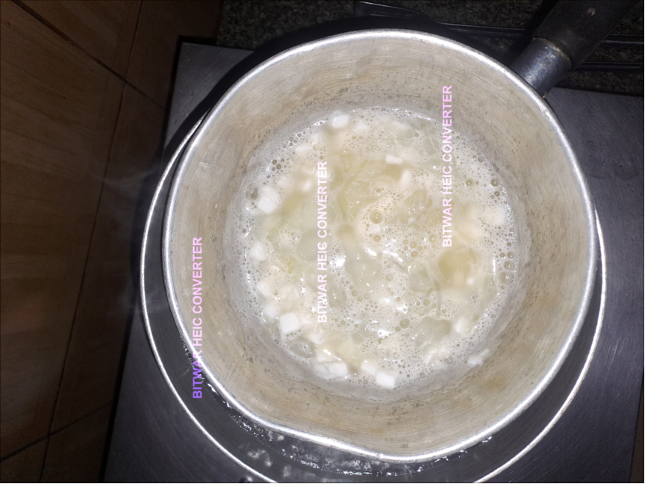

Step 6 :

Pour into Molds Pour the mixture into your soap molds, filling them evenly.

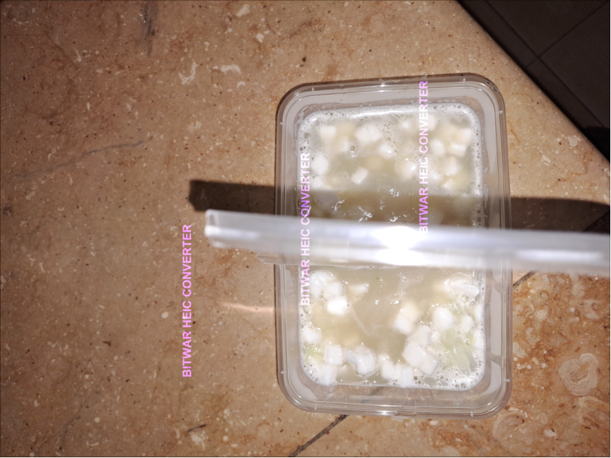

Tap the molds gently on the surface to release any air bubbles.

Step : 7

Allow to Set Let the soap cool and harden for 4 - 5 hours at room temperature or in the refrigerator for faster setting.Ensure the soap is fully solidified before unmolding.

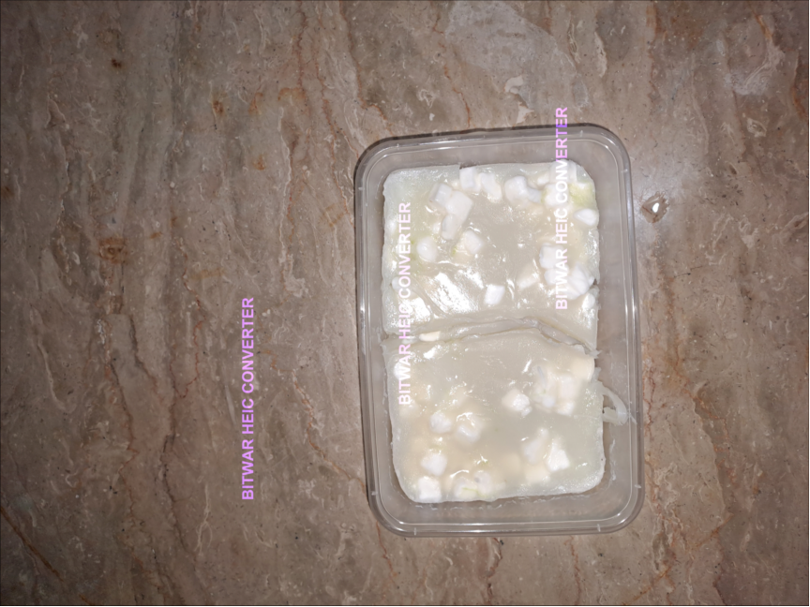

Step : 8

Remove from Molds Carefully remove the soap from the molds by gently pressing from the bottom.

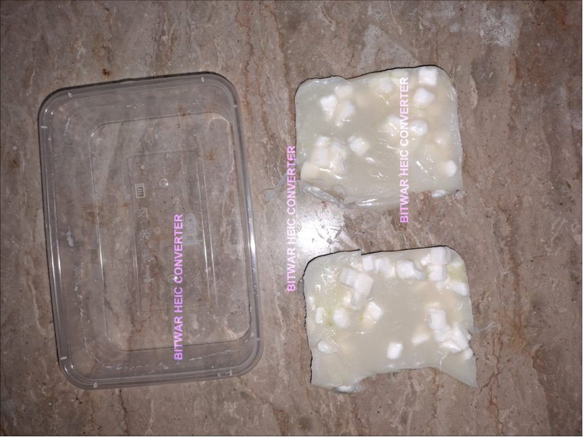

Here is a link :

[https://youtube.com/shorts/RJoohLf7Boo?si=VWBDAtg9yC72aL3S](https://youtube.com/shorts/RJoohLf7Boo?si=VWBDAtg9yC72aL3S" \t "https://mail.google.com/mail/u/0/" \l "inbox/_blank)